Министерство образования Республики Беларусь

Учреждение образования

«Брестский государственный технический университет»

Кафедра ИИТ

Лабораторная работа №1

за 1 семестр

По дисциплине: «ТРИПС»

Тема: «Основные элементы управления WPF»

Выполнила:

Студент 2 курса

Группы ПО-4(1)

Иваненко И. Л.

Проверил:

Войцехович О.Ю.

2020

Лабораторная работа №1

Основные элементы управления WPF

Цель работы: изучить основные элементы управления WPF.

Задание 1.

Разработать WPF-приложение с меню, панелью инструментов и строкой состояния. С помощью пунктов меню пользователь может изменять цвет фона окна, получить информацию о разработчике, а также закрыть окно. Кнопки панели инструментов дублируют команды меню. При наведении на пункты меню или кнопки панели инструментов в строке состояния отображается информация об этих элементах управления.

Код программы:

MainWindow.xaml:

<Window x:Class="Graphical_Designer.MainWindow"

xmlns="http://schemas.microsoft.com/winfx/2006/xaml/presentation"

xmlns:x="http://schemas.microsoft.com/winfx/2006/xaml"

xmlns:d="http://schemas.microsoft.com/expression/blend/2008"

xmlns:mc="http://schemas.openxmlformats.org/markup-compatibility/2006"

xmlns:local="clr-namespace:Graphical_Designer"

mc:Ignorable="d"

Title="Graphical Designer" Height="450" Width="800">

<Grid Name = "MainGrid">

<Menu MouseEnter="Menu_MouseEnter" MouseLeave="ClearStatusLine" Background="Gainsboro" VerticalAlignment="Top" Height="40">

<MenuItem Header="Menu" Height="40" Width="70" FontSize="20" FontWeight="DemiBold">

<MenuItem Name="Background_White" Header="Background Color: White" Click="Background_White_Click" MouseEnter="WhiteButton_MouseEnter" MouseLeave="ClearStatusLine"/>

<MenuItem Name="Background_Red" Header="Background Color: Red" Click="Background_Red_Click" MouseEnter="RedButton_MouseEnter" MouseLeave="ClearStatusLine"/>

<MenuItem Name="Background_Orange" Header="Background Color: Orange" Click="Background_Orange_Click" MouseEnter="OrangeButton_MouseEnter" MouseLeave="ClearStatusLine"/>

<MenuItem Name="Background_Yellow" Header="Background Color: Yellow" Click="Background_Yellow_Click" MouseEnter="YellowButton_MouseEnter" MouseLeave="ClearStatusLine"/>

<MenuItem Name="Background_Green" Header="Background Color: Green" Click="Background_Green_Click" MouseEnter="GreenButton_MouseEnter" MouseLeave="ClearStatusLine"/>

<MenuItem Name="Background_LightBlue" Header="Background Color: LightBlue" Click="Background_LightBlue_Click" MouseEnter="LightBlueButton_MouseEnter" MouseLeave="ClearStatusLine"/>

<MenuItem Name="Background_Blue" Header="Background Color: Blue" Click="Background_Blue_Click" MouseEnter="BlueButton_MouseEnter" MouseLeave="ClearStatusLine"/>

<MenuItem Name="Background_Purple" Header="Background Color: Purple" Click="Background_Purple_Click" MouseEnter="PurpleButton_MouseEnter" MouseLeave="ClearStatusLine"/>

<MenuItem Name ="Developer_Info" Header="Who is the developer?" Click="Info_Click" MouseEnter="Info_MouseEnter" MouseLeave="ClearStatusLine"/>

<MenuItem Name ="Close_Window" Header="Close the window" Click="CloseWindow_Click" MouseEnter="CloseWindow_MouseEnter" MouseLeave="ClearStatusLine"/>

</MenuItem>

<ToolBar Height="40" Background="Gainsboro">

<Button Name="WhiteButton" Height="40" Width="40" Background="White" Click="Background_White_Click" MouseEnter="WhiteButton_MouseEnter" MouseLeave="ClearStatusLine"/>

<Button Name="RedButton" Height="40" Width="40" Background="Red" Click="Background_Red_Click" MouseEnter="RedButton_MouseEnter" MouseLeave="ClearStatusLine"/>

<Button Name="OrangeButton" Height="40" Width="40" Background="Orange" Click="Background_Orange_Click" MouseEnter="OrangeButton_MouseEnter" MouseLeave="ClearStatusLine"/>

<Button Name="YellowButton" Height="40" Width="40" Background="Yellow" Click="Background_Yellow_Click" MouseEnter="YellowButton_MouseEnter" MouseLeave="ClearStatusLine"/>

<Button Name="GreenButton" Height="40" Width="40" Background="Green" Click="Background_Green_Click" MouseEnter="GreenButton_MouseEnter" MouseLeave="ClearStatusLine"/>

<Button Name="LightBlueButton" Height="40" Width="40" Background="Cyan" Click="Background_LightBlue_Click" MouseEnter="LightBlueButton_MouseEnter" MouseLeave="ClearStatusLine"/>

<Button Name="BlueButton" Height="40" Width="40" Background="Blue" Click="Background_Blue_Click" MouseEnter="BlueButton_MouseEnter" MouseLeave="ClearStatusLine"/>

<Button Name="PurpleButton" Height="40" Width="40" Background="Purple" Click="Background_Purple_Click" MouseEnter="PurpleButton_MouseEnter" MouseLeave="ClearStatusLine"/>

</ToolBar>

</Menu>

<Button Name="CloseWindow" Width="40" Height="40" BorderThickness="0" HorizontalAlignment="Right" VerticalAlignment="Top" Background="Gainsboro" Click="CloseWindow_Click" MouseEnter="CloseWindow_MouseEnter" MouseLeave="ClearStatusLine">

<Image Source="https://emojio.ru/images/apple-b/274c.png"></Image>

</Button>

<Button Name="Info" Width="40" Height="40" BorderThickness="0" HorizontalAlignment="Right" Margin="0,0,50,0" VerticalAlignment="Top" Background="Gainsboro" Click="Info_Click" MouseEnter="Info_MouseEnter" MouseLeave="ClearStatusLine">

<Image Source="https://avatanplus.com/files/resources/original/5759b69c2046c155367151e4.png"></Image>

</Button>

<StatusBar VerticalAlignment="Bottom" Width="800" Height="30" Background="Gainsboro">

<TextBlock>Status bar: </TextBlock>

<TextBlock Name ="CurrentStatus"/>

</StatusBar>

</Grid>

</Window>

MainWindow.xaml.cs:

using System;

using System.Collections.Generic;

using System.Linq;

using System.Text;

using System.Threading.Tasks;

using System.Windows;

using System.Windows.Controls;

using System.Windows.Data;

using System.Windows.Documents;

using System.Windows.Input;

using System.Windows.Media;

using System.Windows.Media.Imaging;

using System.Windows.Navigation;

using System.Windows.Shapes;

namespace Graphical_Designer

{

/// <summary>

/// Логика взаимодействия для MainWindow.xaml

/// </summary>

public partial class MainWindow : Window

{

public MainWindow()

{

InitializeComponent();

}

private void Menu_MouseEnter(object sender, MouseEventArgs e)

{

CurrentStatus.Text = "Menu";

}

private void Background_White_Click(object sender, RoutedEventArgs e)

{

MainGrid.Background = Brushes.White;

}

private void Background_Red_Click(object sender, RoutedEventArgs e)

{

MainGrid.Background = Brushes.Red;

}

private void Background_Yellow_Click(object sender, RoutedEventArgs e)

{

MainGrid.Background = Brushes.Yellow;

}

private void Background_Green_Click(object sender, RoutedEventArgs e)

{

MainGrid.Background = Brushes.Green;

}

private void Background_Blue_Click(object sender, RoutedEventArgs e)

{

MainGrid.Background = Brushes.Blue;

}

private void Background_LightBlue_Click(object sender, RoutedEventArgs e)

{

MainGrid.Background = Brushes.Cyan;

}

private void Background_Purple_Click(object sender, RoutedEventArgs e)

{

MainGrid.Background = Brushes.Purple;

}

private void Background_Orange_Click(object sender, RoutedEventArgs e)

{

MainGrid.Background = Brushes.Orange;

}

private void WhiteButton_MouseEnter(object sender, MouseEventArgs e)

{

CurrentStatus.Text = "Change background to white";

}

private void RedButton_MouseEnter(object sender, MouseEventArgs e)

{

CurrentStatus.Text = "Change background to red";

}

private void OrangeButton_MouseEnter(object sender, MouseEventArgs e)

{

CurrentStatus.Text = "Change background to orange";

}

private void GreenButton_MouseEnter(object sender, MouseEventArgs e)

{

CurrentStatus.Text = "Change background to green";

}

private void LightBlueButton_MouseEnter(object sender, MouseEventArgs e)

{

CurrentStatus.Text = "Change background to light blue";

}

private void BlueButton_MouseEnter(object sender, MouseEventArgs e)

{

CurrentStatus.Text = "Change background to blue";

}

private void PurpleButton_MouseEnter(object sender, MouseEventArgs e)

{

CurrentStatus.Text = "Change background to purple";

}

private void CloseWindow_Click(object sender, RoutedEventArgs e)

{

Close();

}

private void CloseWindow_MouseEnter(object sender, MouseEventArgs e)

{

CurrentStatus.Text = "Close the window";

}

private void Info_Click(object sender, RoutedEventArgs e)

{

MessageBox.Show("My name is Ivanenko Ivan.I am student of the 2'nd course of FEIS.");

}

private void Info_MouseEnter(object sender, MouseEventArgs e)

{

CurrentStatus.Text = "Who is the developer?";

}

private void YellowButton_MouseEnter(object sender, MouseEventArgs e)

{

CurrentStatus.Text = "Change background to yellow";

}

private void ClearStatusLine(object sender, MouseEventArgs e)

{

CurrentStatus.Text = "";

}

}

}

Результат выполнения:

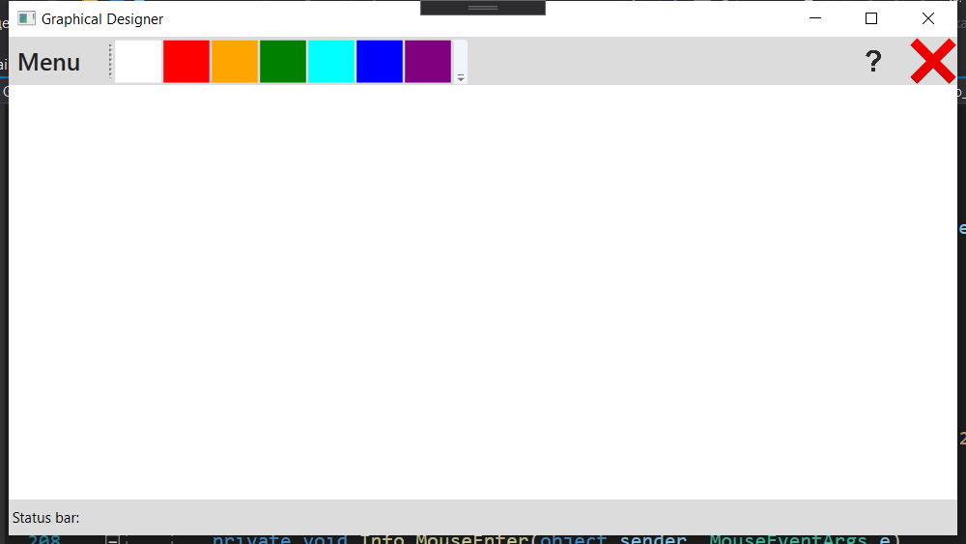

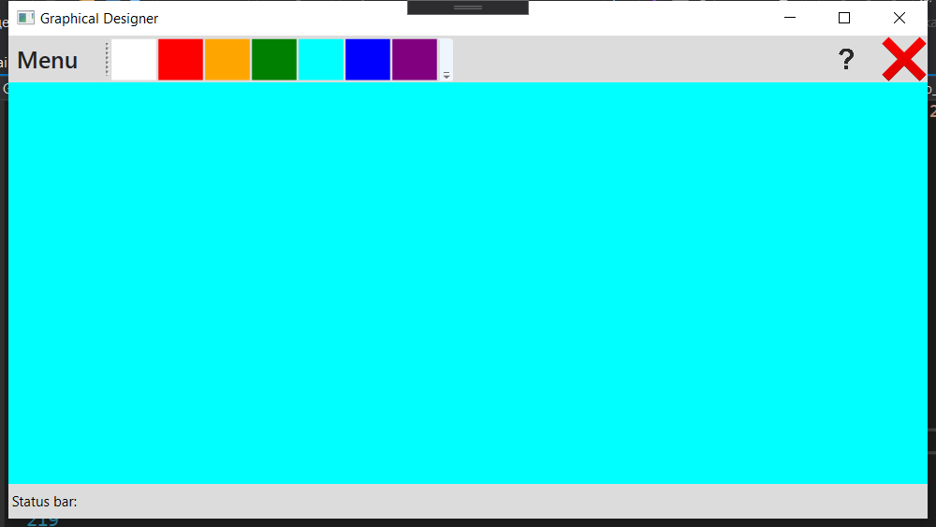

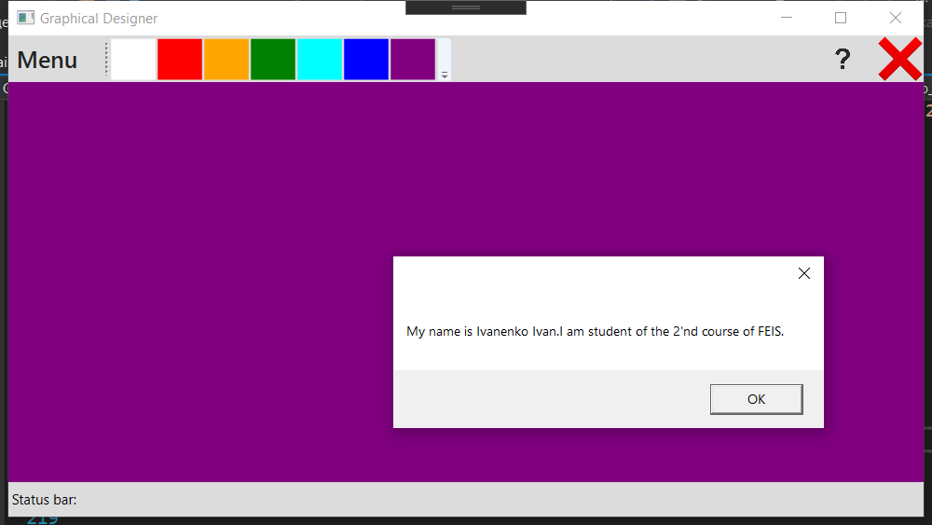

Задание 2:

Разработать WPF-приложение «Графический редактор» с выпадающим списком для выбора цвета кисти, ползунком для выбора размеров кисти и зависимыми переключателями для выбора режима работы: «рисование», «редактирование», «удаление».

Код программы:

MainWindow.xaml:

<Window x:Class="GraphicalDesigner_v2._0.MainWindow"

xmlns="http://schemas.microsoft.com/winfx/2006/xaml/presentation"

xmlns:x="http://schemas.microsoft.com/winfx/2006/xaml"

xmlns:d="http://schemas.microsoft.com/expression/blend/2008"

xmlns:mc="http://schemas.openxmlformats.org/markup-compatibility/2006"

xmlns:local="clr-namespace:GraphicalDesigner_v2._0"

mc:Ignorable="d"

Title="Graphical Designer v2.0" Height="450" Width="800">

<Grid>

<InkCanvas Name="Ink">

<InkCanvas.DefaultDrawingAttributes>

<DrawingAttributes Height="1" Width="1"/>

</InkCanvas.DefaultDrawingAttributes>

</InkCanvas>

<Grid Name="TopPanel" VerticalAlignment="Top" HorizontalAlignment="Left" Width="800" Height="80" Background="Gainsboro">

<TextBlock Text="Choose color:" FontFamily="Arial" FontSize="18" Margin="20, 10, 0, 0"/>

<ComboBox FontFamily="Arial" FontSize="16" Name="ColorsList" Width="200" Height="30" HorizontalAlignment="Left" Margin="20,15,0,0" SelectionChanged="ColorsList_SelectionChanged">

<ComboBoxItem Content="White" FontFamily="Arial" FontSize="16"/>

<ComboBoxItem Content="Black" FontFamily="Arial" FontSize="16"/>

<ComboBoxItem Content="Red" FontFamily="Arial" FontSize="16"/>

<ComboBoxItem Content="Orange" FontFamily="Arial" FontSize="16"/>

<ComboBoxItem Content="Yellow" FontFamily="Arial" FontSize="16"/>

<ComboBoxItem Content="Green" FontFamily="Arial" FontSize="16"/>

<ComboBoxItem Content="Cyan" FontFamily="Arial" FontSize="16"/>

<ComboBoxItem Content="Blue" FontFamily="Arial" FontSize="16"/>

<ComboBoxItem Content="Purple" FontFamily="Arial" FontSize="16"/>

</ComboBox>

<TextBlock Text="Choose mode:" FontFamily="Arial" FontSize="18" Margin="280,10,0,0"/>

<RadioButton Name="DrawingMode" Checked="DrawingModeSelection" Margin="280, 30, 0, 0" FontFamily="Arial" FontSize="12">

Drawing Mode

</RadioButton>

<RadioButton Name="DeletingMode" Checked="DeletingModeSelection" Margin="280, 45, 0, 0" FontFamily="Arial" FontSize="12">

Deleting Mode

</RadioButton>

<RadioButton Name="FormatingMode" Checked="FormatingModeSelection" Margin="280, 60, 0, 0" FontFamily="Arial" FontSize="12">

Formating Mode

</RadioButton>

<TextBlock Text="Choose width:" FontFamily="Arial" FontSize="18" Margin="500,10,0,0"/>

<Slider Name="ChooseWidth" Maximum="100" Value="1" TickPlacement="Both" TickFrequency="10" Margin="400,35,0,0" Width="200" Foreground="Black" ValueChanged="BrushWidthChange"/>

</Grid>

<Button Name="CloseWindow" Width="40" Height="40" BorderThickness="0" VerticalAlignment="Top" HorizontalAlignment="Right" Background="Gainsboro" Click="CloseWindow_Click">

<Image Source="https://emojio.ru/images/apple-b/274c.png"></Image>

</Button>

</Grid>

</Window>

MainWindow.xaml.cs:

using System;

using System.Collections.Generic;

using System.Linq;

using System.Text;

using System.Threading.Tasks;

using System.Windows;

using System.Windows.Controls;

using System.Windows.Data;

using System.Windows.Documents;

using System.Windows.Input;

using System.Windows.Media;

using System.Windows.Media.Imaging;

using System.Windows.Navigation;

using System.Windows.Shapes;

namespace GraphicalDesigner_v2._0

{

/// <summary>

/// Логика взаимодействия для MainWindow.xaml

/// </summary>

public partial class MainWindow : Window

{

public MainWindow()

{

InitializeComponent();

}

//choosing drawing mode

private void DrawingModeSelection(object sender, RoutedEventArgs e)

{

Ink.EditingMode = InkCanvasEditingMode.Ink;

}

private void DeletingModeSelection(object sender, RoutedEventArgs e)

{

Ink.EditingMode = InkCanvasEditingMode.EraseByStroke;

}

private void FormatingModeSelection(object sender, RoutedEventArgs e)

{

Ink.EditingMode = InkCanvasEditingMode.Select;

}

//choosing brush color

private void ColorsList_SelectionChanged(object sender, SelectionChangedEventArgs e)

{

ComboBoxItem selectedItem = (ComboBoxItem)(ColorsList.SelectedValue);

string value = (string)(selectedItem.Content);

Ink.DefaultDrawingAttributes.Color = (Color)ColorConverter.ConvertFromString(value);

}

//choosing brush width

private void BrushWidthChange(object sender, RoutedPropertyChangedEventArgs<double> e)

{

Ink.DefaultDrawingAttributes.Width = ChooseWidth.Value;

Ink.DefaultDrawingAttributes.Height = ChooseWidth.Value;

}

private void CloseWindow_Click(object sender, RoutedEventArgs e)

{

Close();

}

}

}

Результат выполнения:

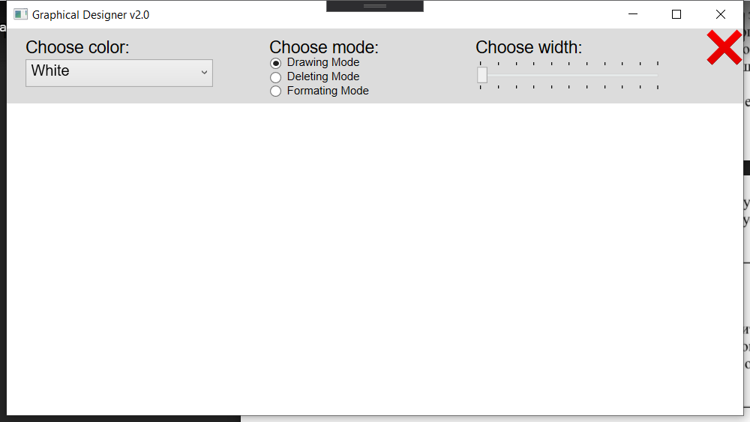

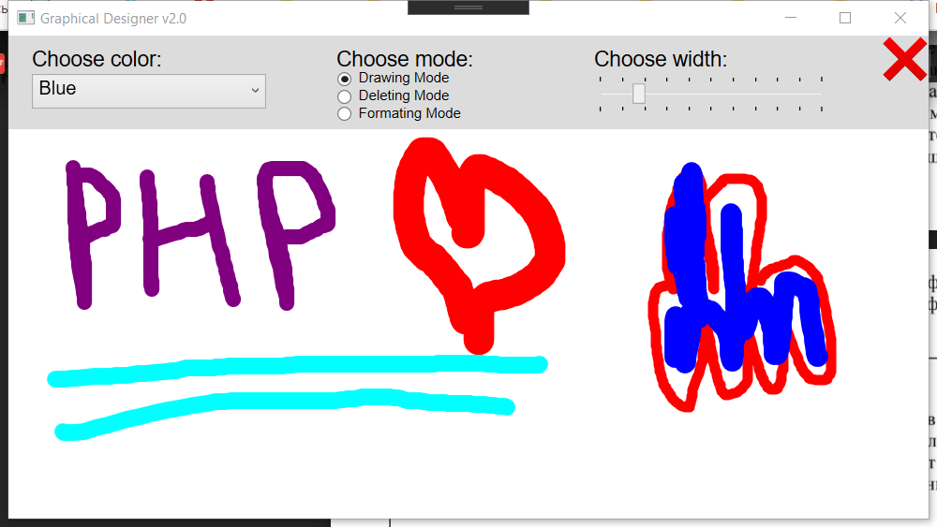

Вывод: В ходе выполнения данной лабораторной работы я изучил основы разработки wpf-приложений.